**CMPS115 Sprint 1 Plan**

**Goal**

After the first sprint, it should be possible for an author to upload comics and for a user to view them in sequential order.

**Task Listing**

**User Story 1** - As an author, I want to have my own account so that I can manage the comics

that I uploaded.

* Write a postgres schema for the Account table (3 hrs).
* Build a NodeJs API for logging in, logging out, and registering (8 hrs).
* Integrate email-sending into the web comic viewer (6 hrs).
* Build the API for resetting passwords (5 hrs).
* Build the UI for logging in and registering (7 hrs).

*Total Time - 29 hrs*

**User Story 2** - As an author, I want to create comics with titles so that the reader knows what

comics they are reading.

* Write a postgres schema for a comic. (4 hrs).
* Write an API endpoint for creating new comics (3 hrs).
* Write an API endpoint to retrieve a single comic (4 hrs).
* Write an API endpoint to retrieve a list of comics (4 hrs).
* Build the UI for creating a new comic (5 hrs).

*Total Time - 20 hrs*

**User Story 3** - As an author, I want to upload my comic pages so that readers can view them.

* Establish connection between the NodeJS server and Google Cloud Storage (6 hrs).
* Build the API to upload a comic page (5 hrs).
* Build the UI for an author to upload their images (6 hrs).

*Total Time - 17 hrs*

**User Story 4** - As a reader, I want to have page navigation so that I can easily return to the

page that I left off on.

* Write Typescript logic that will determine the next comic (1 hr).
* Make the UI for the comic reader (7 hrs).

*Total Time - 8 hrs*

**Team Roles**

Will: Product Owner, Fullstack Dev

Myron: Scrum Master, Backend Dev

Sammy: Scrum Master, Backend Dev

James: Backend Dev

Mehtab: Backend Dev

Alan: Frontend Dev

**Initial Task Assignment**

Will: User story 1 - Write a postgres schema for the Account table.

Myron: User story 1 - Build a NodeJs API for logging in, logging out, and registering.

Sammy: User story 2 - Write an API endpoint to create a new comic.

James: User story 2 - Build the UI for creating a new comic.

Mehtab: User story 3 - Establish a connection between the NodeJS server and Google

Cloud Storage.

Alan: User story 4 - Write Typescript logic to determine the next comic.

**Initial Scrum Board**

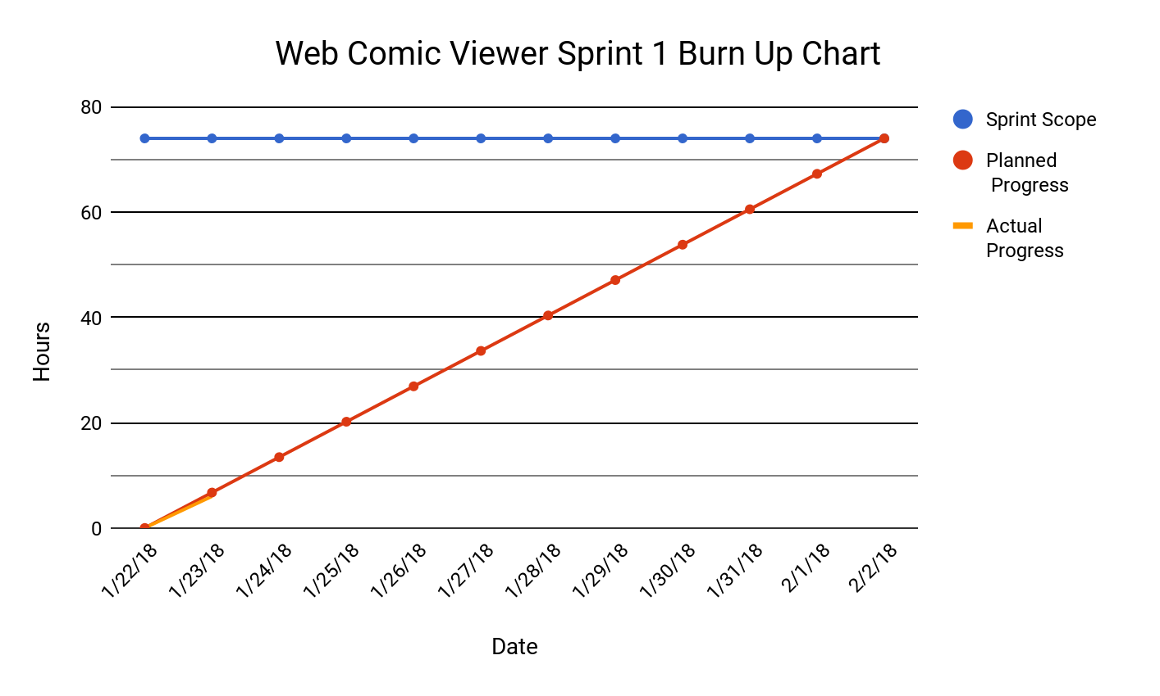

# Scrum Times

Monday: 4:00-4:15

Tuesday: 4:10-4:25 - TA meeting

Thursday: 3:30-3:45